# Abstract

Single Page Website Creation

This report presents the development of a single-page website using HTML, CSS, Bootstrap, and JavaScript. The website features a navigation bar with smooth scrolling functionality, enabling users to seamlessly navigate between different sections. The design aims to demonstrate the integration of responsive design practices with modern web development frameworks.

# Objective

The objective of this project is to create a visually appealing and user-friendly single-page website that utilizes Bootstrap for responsive design and custom JavaScript for enhanced user interaction. The website should include multiple sections accessible through a navigation bar with smooth scrolling effects.

# Introduction

In the current digital age, web development is increasingly focusing on single-page applications (SPAs) due to their fast performance and seamless user experience. This project utilizes Bootstrap for styling and layout, and jQuery for implementing smooth scrolling between sections. The use of Bootstrap ensures that the website is mobile-responsive, while jQuery enhances the user interface with smooth transitions.

# Methodology

**HTML Structure**: The basic structure of the website was built using HTML5. The document includes a navigation bar and three content sections, each identified by a unique ID.

**Styling with Bootstrap and Custom CSS**: Bootstrap was included to provide a responsive layout and pre-designed components. Custom CSS was used to specify the height of each section and enable smooth scrolling behavior.

**JavaScript for Interactivity**: jQuery was utilized to add smooth scrolling functionality to the navigation links. A script listens for clicks on navigation links and animates the scroll to the corresponding section.

**Testing**: The website was tested on various devices and screen sizes to ensure responsive design and smooth scrolling functionality.

**Index.html**

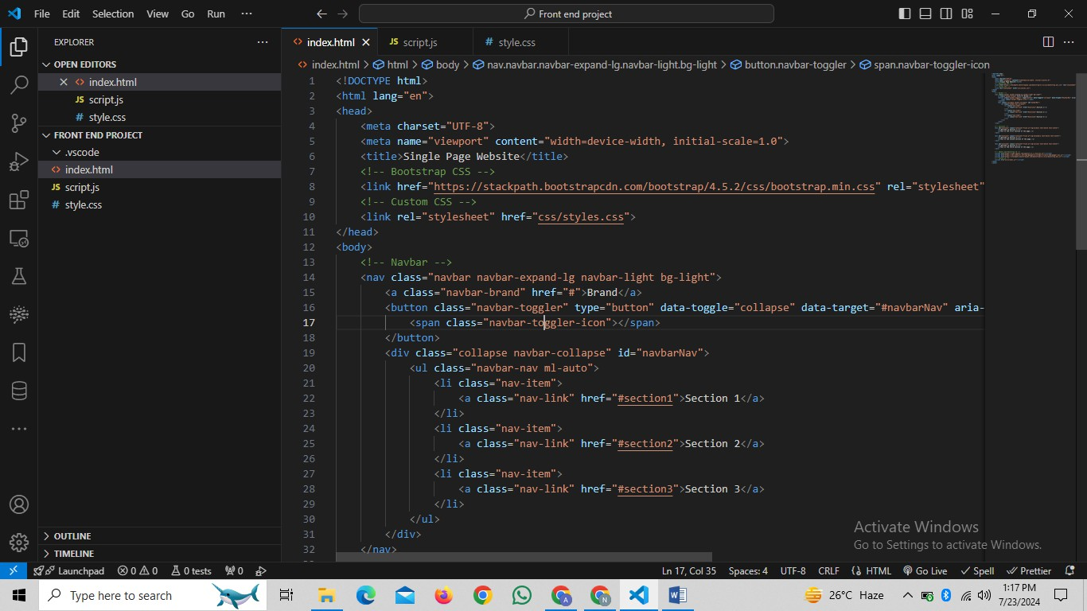

**Script.js**

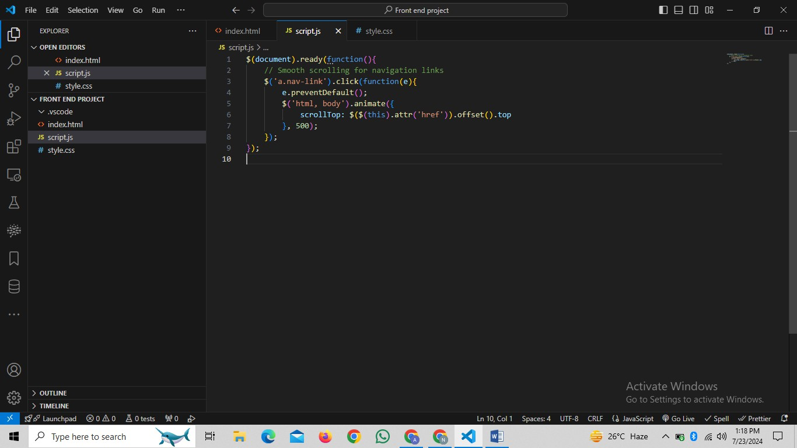

**Style.css**

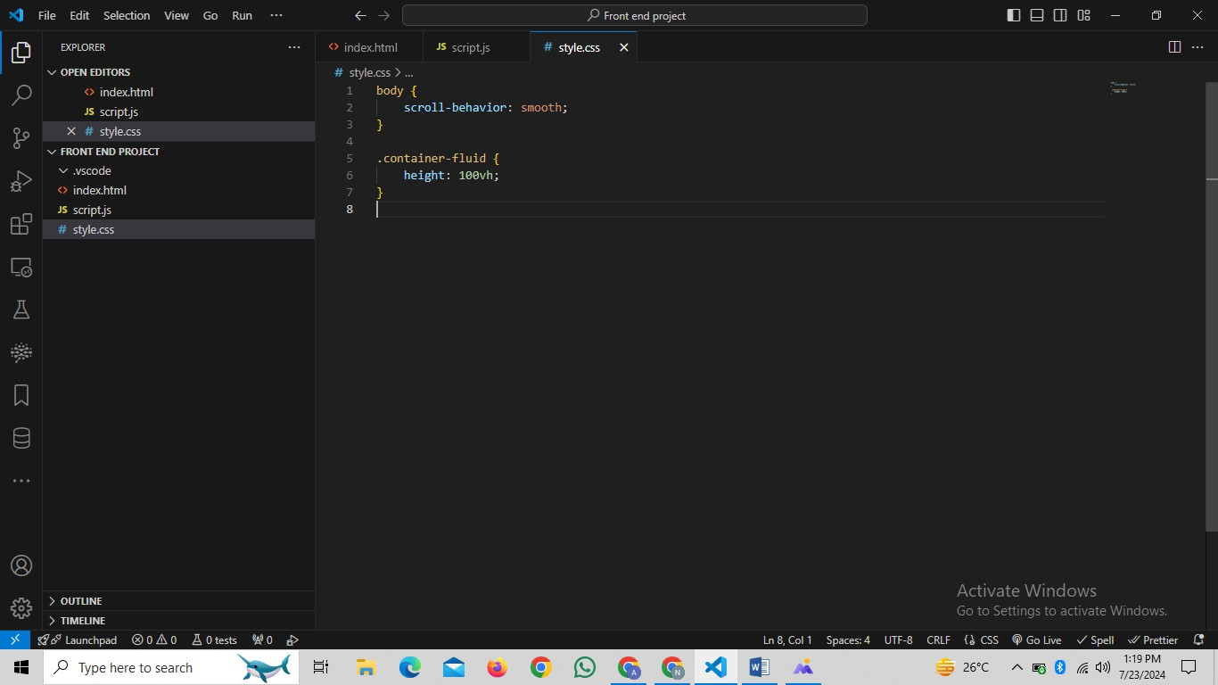

**Output:-**

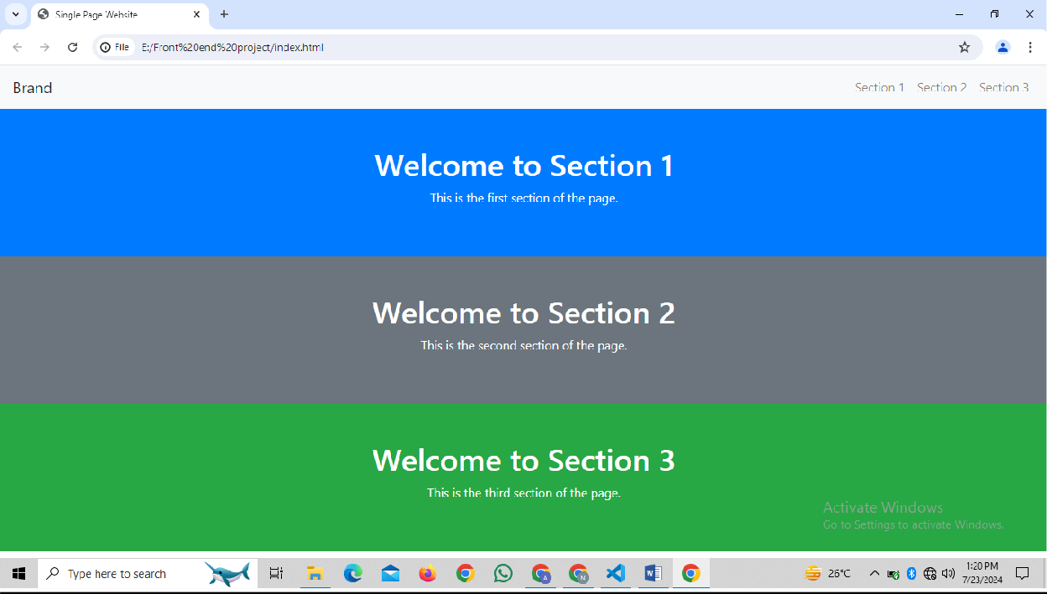

# Conclusion

The project successfully demonstrates the creation of a single-page website using Bootstrap and custom JavaScript for smooth scrolling. The website is responsive and provides a seamless navigation experience. This approach can be further extended with more complex features and additional sections to enhance user interaction and content delivery.